Registering for Classes / Lessons

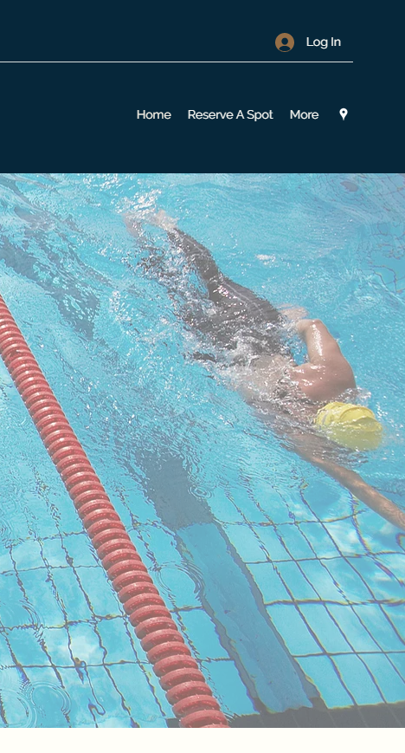

1. This is the homepage for the City Of Cheyenne’ WebTrac Registration site. Go to Cheyenneaquatics.com then click on ‘More’ then find the [Lessons and Class Registrations](https://www.cheyenneaquatics.com/about-us) button and click on that. Once you are on that page there is button that says Register now!

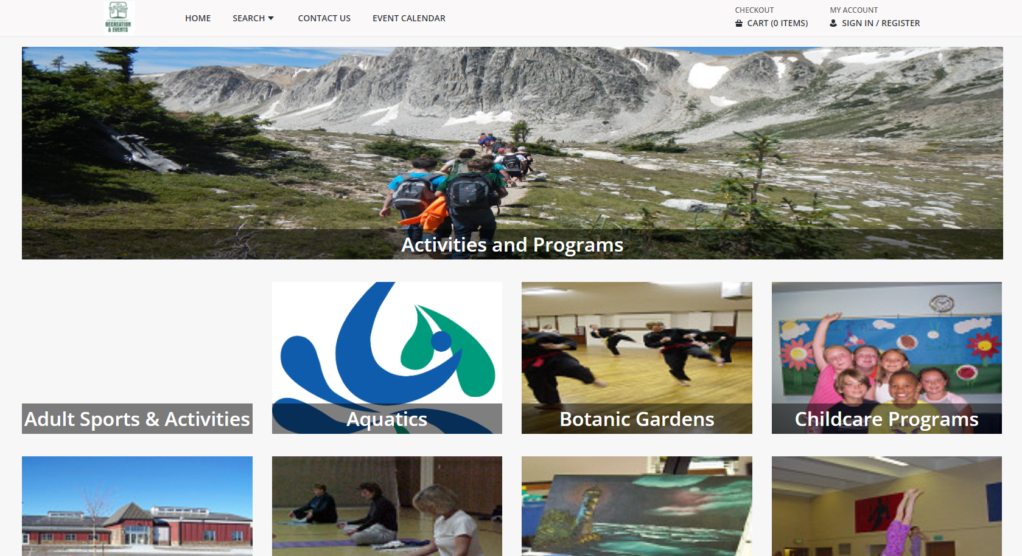

2. Find the button that says “Aquatics”; click the button once. This will take you to the WebTrac Activity Search page.

3. The page below is the Activity Search page. Any active classes or lessons will be listed here. For this instruction page we will be working with the Aqua Exercise Activity.

4. Once you click the activity you will receive more information on it. Which includes the beginning and end dates, class times, days that class is held and the cost of the class.

5. There is a small check box next to the word **“Available”** that needs to be selected. Once you select that checkbox the class will be added to your cart. This will be noted on the bottom of the screen by the words “Selected Items”. If your selection has been made correctly you may click **“Add to Cart”.**

6. If you are not signed in when you add an item to your cart WebTrac will prompt you to do so. Enter your Username and Password in order to continue with checking out. Click ‘Login’ when ready to move on. **NOTE: If you have not created an account you can do so by following the instructions on the “Create a WebTrac Account” Instructions. You must have an account to continue. **

7. After logging in you will be sent to your shopping cart, this will list all the classes or lessons you have signed up for. You can remove classes you added by mistake by clicking the **‘Remove’** button. If you would like to add more classes or lessons click **‘Continue Shopping”**. If you are ready to pay click **“Proceed to Checkout”**

8. This is the Checkout Confirmation page. A receipt will be sent to the email the Aquatic center has one file for you. If you would also like it to be sent to a secondary email, you can enter that in the ‘Email Address’ box.

**YOU HAVE SUCESSFULLY REGISTERED FOR A CLASS! KEEP AN EYE ON YOUR EMAIL FOR CONFIRMATION!**